Agricultural Commodities Price Trends across India(2018)

1. Project Overview and Objective
The goal of this project is to transform raw agricultural commodity data into meaningful insights through data cleaning and analysis in Excel, followed by the development of interactive Power BI dashboards to monitor trends and support data-driven decision-making.

2. Data Source
- Source Description and Timeline: India Data Portal and 2015-2024
- Domain: Commerce

3. Problem Statement
- For understanding market trends,regional price variations and the impact of economic policies on commodities prices.

4. Attribute (Column /Features) Details:
Attribute Name | Data Type | Description
ID | Integer | Unique identifier for each commodities
State Name | Text | Name of the state
Commodities | Text | Includes agricultural products
Price | Integer | Price of individual Commodities

5. Tools & Technologies
- Excel: Data cleaning, transformation, and Data modelling
- Power BI: DAX calculations, visualization, and interactive dashboard creation.

6. Data Pre-Processing (Excel / Power Query)
Tasks Performed:
- Data Cleaning & Transformation: Removed duplicates, handled missing values, standardized formats,created calculated fields and data models.
- Filtering & Sorting: Organized data to focus on relevant records.
- Date Model: Date table is created.
- Fact table: 1. Daily Retail Price
2.Wholesale price of India
3.Wholesale price of state.

- Dimensional table: Date Table

7. Data Modelling and DAX (Power BI)
- Data Model: To support analytical reporting, a star schema was implemented using three tables. The Date key was used to establish relationships between the fact table and the dimension table, enabling efficient aggregation and analysis of agricultural commodity prices across time.
- Cardinality: The relationship between the Date Dimension table and the Fact table follows a one-to-many (1:*) cardinality, where each unique date in the dimension table is associated with multiple agricultural commodity records in the fact table. This structure supports efficient time-based analysis and reporting.
SCREENSHOT OF DATA MODELLING
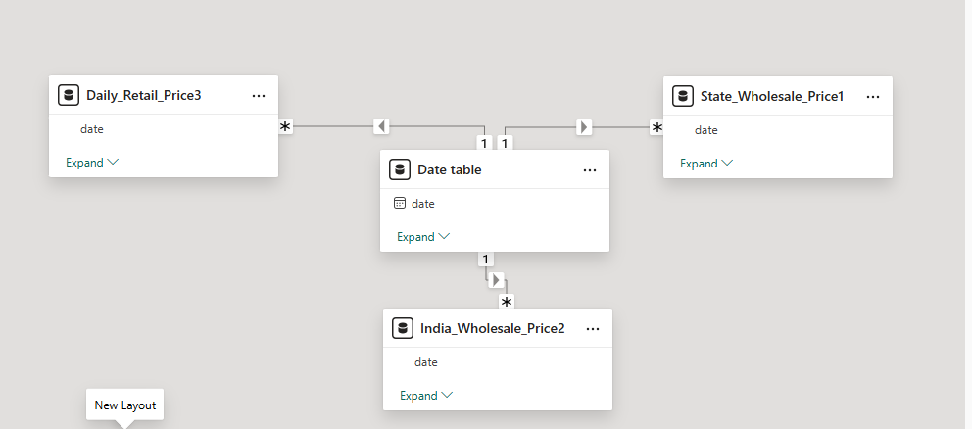

- Calculated Columns & DAX Measures: DAX calculated columns and measures were created to enhance data analysis and reporting capabilities. Key metrics such as Retail Month, Retail Margin, State Price Category, Price Volatility, Average vs Modal Difference, Year, Average Retail Price,Average State & India Wholesale Price, Highest Rank State, Number of States and Number of Commodities were derived to provide deeper insights into pricing patterns and trends.

8. Analysis and Visualizations (Power BI)
- Dashboard Features: Multiple visualizations were developed to address the project objectives and present insights effectively. Bar and column charts were used for commodity price comparisons, price volatility analysis, and identifying high-priced commodities, while line and area charts highlighted price and margin trends over time. Scatter plots, waterfall charts, pie/donut charts, funnel charts, and geo maps were utilized to analyze price distribution, price range differences, monthly and state-wise price patterns, state rankings, and geographical variations in prices.
- Filters and slicers were incorporated across the dashboards. They allow users to dynamically filter information by date, commodity, and state, providing deeper insights and improving the overall user experience.
SCREENSHOT OF DASHBOARD /REPORT
- Commodities Insights
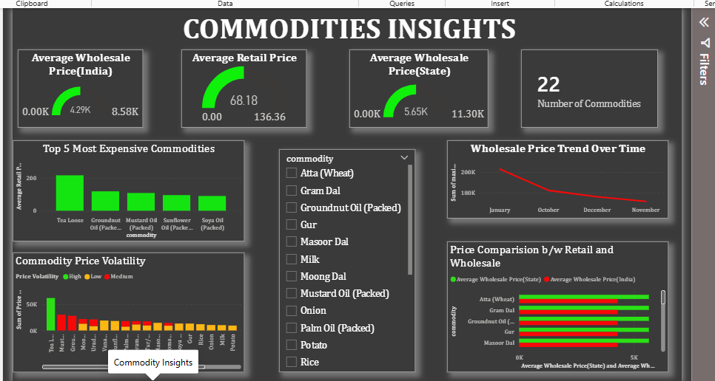
- State Insights
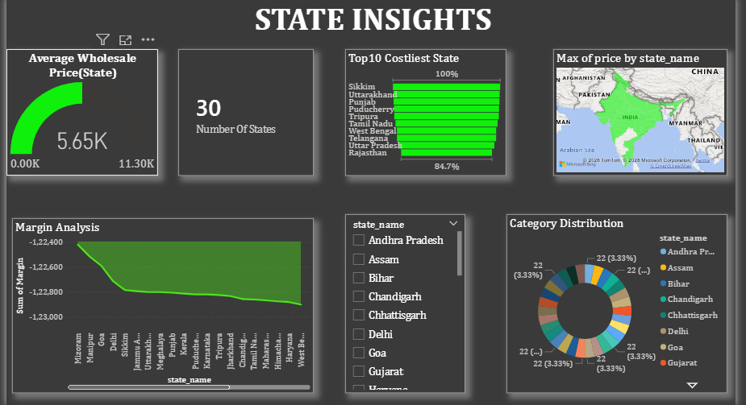
- Price Insights
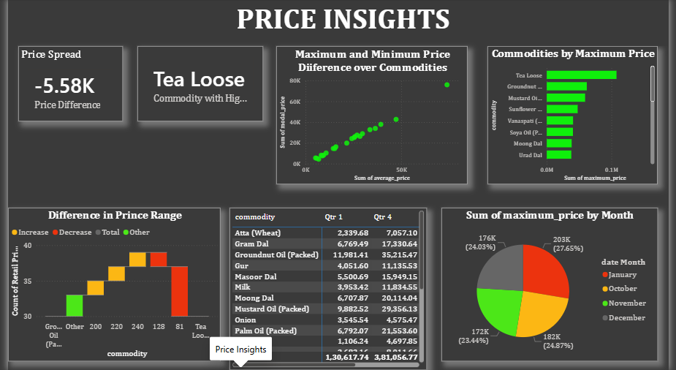

9. Insights
- Key Findings: The study identified notable differences in commodity prices across states and market types. While some commodities showed stable pricing over time, others experienced higher price volatility and wider retail-wholesale price spreads.
- Provide the analysis insights:
    - Descriptive
The analysis summarized retail and wholesale commodity prices across different states and time periods. It identified the highest and lowest priced commodities, state-wise price variations, and overall pricing trends.
Diagnosis
The analysis revealed that differences in commodity prices were influenced by location, market type (retail vs. wholesale), and commodity category. Some commodities showed higher price volatility, resulting in larger price spreads.
    - Predictive
Based on historical price patterns, commodities with consistently high prices are likely to remain relatively expensive in the near future. Stable commodities are expected to maintain similar pricing trends unless significant market changes occur.
    - Prescriptive
Regular monitoring of price spreads can help identify commodities with unusual price fluctuations. Decision-makers can focus on commodities and states with high price volatility to improve pricing transparency and market efficiency.
10. Conclusions
This project analyzed retail and wholesale commodity prices using Excel and Power BI to uncover pricing trends, state-wise variations, and price spreads. The findings demonstrated the value of data analytics in understanding market behavior and supporting informed decision-making through interactive dashboards and visualizations.

